PostgreSQL CREATE TRIGGER example
The following statement creates a new table called employees:
CREATE TABLE employees(
id INT GENERATED ALWAYS AS IDENTITY,
first_name VARCHAR(40) NOT NULL,
last_name VARCHAR(40) NOT NULL,
PRIMARY KEY(id)
);

Note that if your database already has the employees table, you can drop it first before creating a new one:
DROP TABLE IF EXISTS employees;
Suppose that when the name of an employee changes, you want to log it in a separate table called employee_audits :
CREATE TABLE employee_audits (
id INT GENERATED ALWAYS AS IDENTITY,
employee_id INT NOT NULL,
last_name VARCHAR(40) NOT NULL,
changed_on TIMESTAMP NOT NULL
);
First, create a new function called log_last_name_changes:
CREATE OR REPLACE FUNCTION log_last_name_changes()
RETURNS TRIGGER
LANGUAGE PLPGSQL
AS
$$
BEGIN
IF NEW.last_name <> OLD.last_name THEN
INSERT INTO employee_audits(employee_id,last_name,changed_on)
VALUES(OLD.id,OLD.last_name,now());
END IF;

RETURN NEW;
END;
$$
The function inserts the old last name into the employee_audits table including employee id, last name, and the time of change if the last name of an employee changes.
The OLD represents the row before the update while the NEW represents the new row that will be updated. The OLD.last_name returns the last name before the update and the NEW.last_name returns the new last name.
Second, bind the trigger function to the employees table. The trigger name is last_name_changes. Before the value of the last_name column is updated, the trigger function is automatically invoked to log the changes.
CREATE TRIGGER last_name_changes
BEFORE UPDATE
ON employees
FOR EACH ROW
EXECUTE PROCEDURE log_last_name_changes();
Third, insert some rows into the employees table:
INSERT INTO employees (first_name, last_name)
VALUES ('John', 'Doe');

INSERT INTO employees (first_name, last_name)
VALUES ('Lily', 'Bush');
Fourth, examine the contents of the employees table:
SELECT * FROM employees;

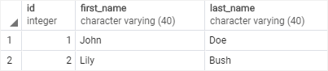
Suppose that Lily Bush changes her last name to Lily Brown.
Fifth, update Lily’s last name to the new one:
UPDATE employees
SET last_name = 'Brown'
WHERE ID = 2;
Sixth, check if the last name of Lily has been updated:
SELECT * FROM employees;

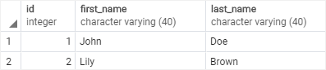
The output indicates that Lily’s last name has been updated.
Finally, verify the contents of the employee_audits table:

SELECT * FROM employee_audits;
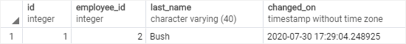
The change was logged in the employee_audits table by the trigger.

